**Almendria@Discord Reform**

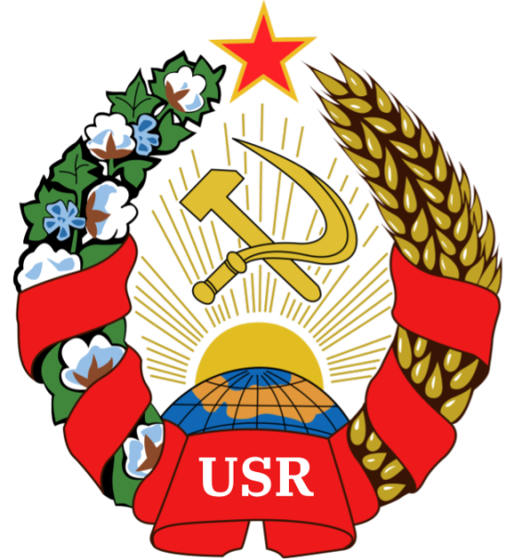

**FROM THE OFFICE OF THE GENERAL SECRETARY OF THE COMMUNIST PARTY AND OF ALMENDRIA**

# **I. Member Entry Reform**

1. New members to Almendria@Discord shall be allowed to connect in chats without the need for registration in AlmChat
2. Non-almchat members will not be allowed to participate in politics or economics.
3. Non-almchat members shall not be Almendrian or USR citizens, and as such receive none of the rights of one.
4. Non-almchat members shall be known as Server Members and given a role as such. This role shall be below bots.

# **II. Community Features**

1. Discord community features shall be enabled on Almendria@Discord
2. We shall aim to become a Discord Partner by 2023
3. We shall aim to be making profit off Almendria@Discord by the end of 2023.

# **III. Relation with AlmChat**

1. AlmChat shall remain the official and encouraged platform for the USR
2. Almendria@Discord shall encourage utilization of AlmChat
3. Any users without AlmChat may not receive any roles in Almendria@Discord apart from the server member role.

# **IV. Ownership of Almendria@Discord**

1. Almendria@Discord shall be oficially owned by AlmChat Communications, the official communications **state owned** company, and shall be treated as a state owned enterprise.
2. The CEO of AlmChat Communications shall be TIZIAN ARUNA, and the Board of Directors shall be composed as follows

* Kamerade Terry McKeen III, as SCEO (Sub Chief Executive Officer)
* Kamerade Zeke Edges, as COO (Chief Operations Officer)
* Kamerade Johann Kummel, as CFO (Chief Financial Officer)

Signed,

CEO of AlmChat Communications, Tizian Aruna.